Lab - Sonarqube Integration with Nodejs Application
In this lab, we will create a continuous integration pipeline to build, test and scan code (via sonarqube) and publish a nodejs application artefact.

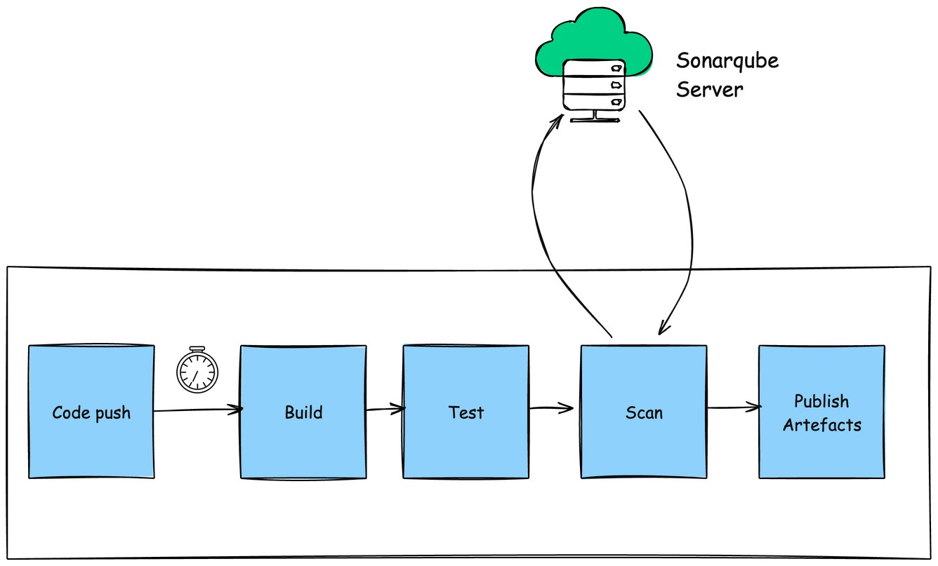

Sonarqube is a famous Code scanning tool to identify the security vulnerabilities, code quality, etc.

Pre-Requisite:
- Github account
- Sonarqube setup up and running (If don’t have a setup, please complete the previous lab)

Learning Objectives:
- Create a GitHub Actions workflow (YAML file)
- Integrate Pipeline execution with Sonarqube
- Publish build artifacts using the appropriate permissions and tokens.
- Gain confidence in using GitHub Actions through a hands-on, step-by-step exercise.

Steps to follow:
- Fork the application code repository from this code repository - Sample Nodejs application
- Clone the code locally
- Add a .github/workflow folder
- Add a yaml file with name ci-sonar.yml
- Copy the code mentioned below.

CI Pipeline Code

name: Continuous Integration Pipeline with SonarQube
on:
workflow_dispatch
# Define permissions for the workflow
permissions:
contents: read
actions: read
checks: write
pull-requests: write
jobs:
build-and-test:
runs-on: ubuntu-latest
environment: dev
steps:
- name: Checkout code
uses: actions/checkout@v4
- name: Setup Node.js
uses: actions/setup-node@v4
with:
node-version: 18.x
cache: 'npm'
cache-dependency-path: 'package-lock.json'
- name: Install dependencies
run: npm ci
- name: Build the application (optional)
run: |
npm run build 2>/dev/null || echo "No build script found, skipping build step"
- name: Run unit tests with coverage and JUnit reports
env:
JEST_JUNIT_OUTPUT: coverage/junit.xml
run: npm run test:ci
- name: Publish test results to Checks
uses: dorny/test-reporter@v1
if: always()
with:
name: Jest Test Results
path: coverage/junit.xml
reporter: jest-junit
fail-on-error: true
- name: Upload test results to GitHub
uses: actions/upload-artifact@v4
if: always()
with:
name: test-results-node
path: coverage/
retention-days: 30
- name: SonarQube Scan
uses: SonarSource/sonarqube-scan-action@v6.0.0
env:
SONAR_HOST_URL: ${{ secrets.SONAR_HOST_URL }}
SONAR_TOKEN: ${{ secrets.SONAR_TOKEN }}
with:
args: >
-Dsonar.projectKey=sample-node-app-saurabh
-Dsonar.organization=sda
-Dsonar.token=${{ secrets.SONAR_TOKEN }}
-Dsonar.host.url=${{ secrets.SONAR_HOST_URL }}
-Dsonar.sources=.
-Dsonar.exclusions=node_modules/**,coverage/**,tests/**,**/*.test.js,**/*.spec.js
-Dsonar.tests=tests/
-Dsonar.test.inclusions=**/*.test.js,**/*.spec.js
-Dsonar.coverage.exclusions=node_modules/**,coverage/**,tests/**,**/*.test.js,**/*.spec.js
- name: Create deployment package
run: |
set -euo pipefail
STAGING="$GITHUB_WORKSPACE/deployment-package"
rm -rf "$STAGING"
mkdir -p "$STAGING"
[ -d public ] && cp -r public "$STAGING/" || echo "No public/ directory found"
[ -d node_modules ] && cp -r node_modules "$STAGING/" || echo "No node_modules/ directory found"
[ -f server.js ] && cp server.js "$STAGING/" || echo "No server.js found"
cp package.json "$STAGING/"
cp package-lock.json "$STAGING/"
[ -f README.md ] && cp README.md "$STAGING/" || true
[ -f Dockerfile ] && cp Dockerfile "$STAGING/" || echo "No Dockerfile found"
(cd "$STAGING" && npm pkg delete devDependencies || true)
TS="$(date +%Y%m%d-%H%M%S)"
SHORT_SHA="${GITHUB_SHA::7}"
ZIP_NAME="deployment-package-${SHORT_SHA}-${TS}.zip"
(cd "$GITHUB_WORKSPACE" && zip -r "$ZIP_NAME" "deployment-package")
echo "ZIP_NAME=$ZIP_NAME" >> "$GITHUB_ENV"
- name: Upload deployment package artifact
uses: actions/upload-artifact@v4
with:
name: deployment-package-node-${{ github.run_number }}
path: ${{ env.ZIP_NAME }}
retention-days: 90

Code Explanation
Workflow name
Continuous Integration Pipeline with SonarQube → a CI pipeline you can run manually.
Permissions
Allows the workflow to read code, run actions, and publish test results or artifacts.
Job: build-and-test
Runs on Ubuntu in the dev environment. Steps:
- Checkout code → pulls your repo code into the runner.
- Setup Node.js → installs Node.js 18.x and enables npm caching.
- Install dependencies → runs npm ci to install packages.
- Build app (optional) → tries npm run build, skips if no build script.
- Run tests → runs unit tests with coverage and saves JUnit XML report.
- Publish test results → shows test results in GitHub Checks.
- Upload test results → saves coverage and reports as workflow artifacts.
- SonarQube Scan → analyzes code quality and coverage, uploads results to SonarQube (using secrets for token and server URL).
- Create deployment package → collects app files (code, configs, node_modules, Dockerfile, etc.), removes dev dependencies, zips into a package with commit info.
- Upload deployment package → saves the zip file as an artifact for later deployment.

Add Sonarqube URL and TOKEN in Github Actions Repository

Navigate to the Settings tab on your repository.

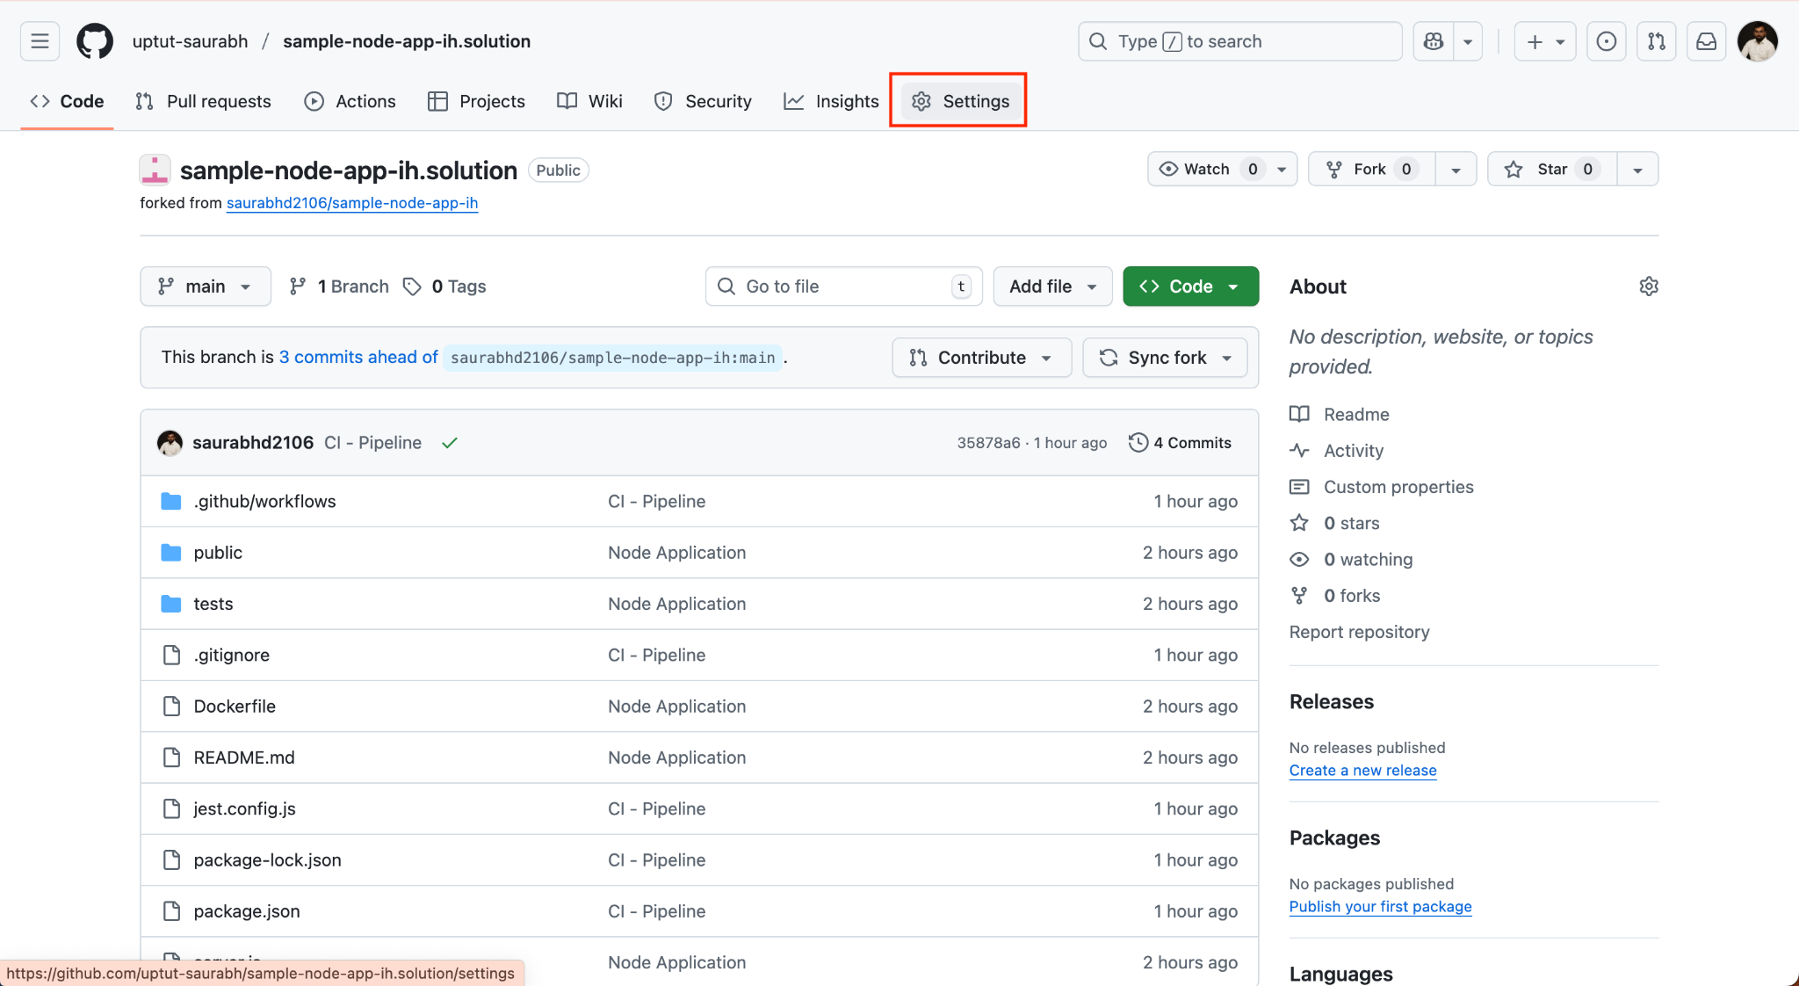

Select Secrets and Variables

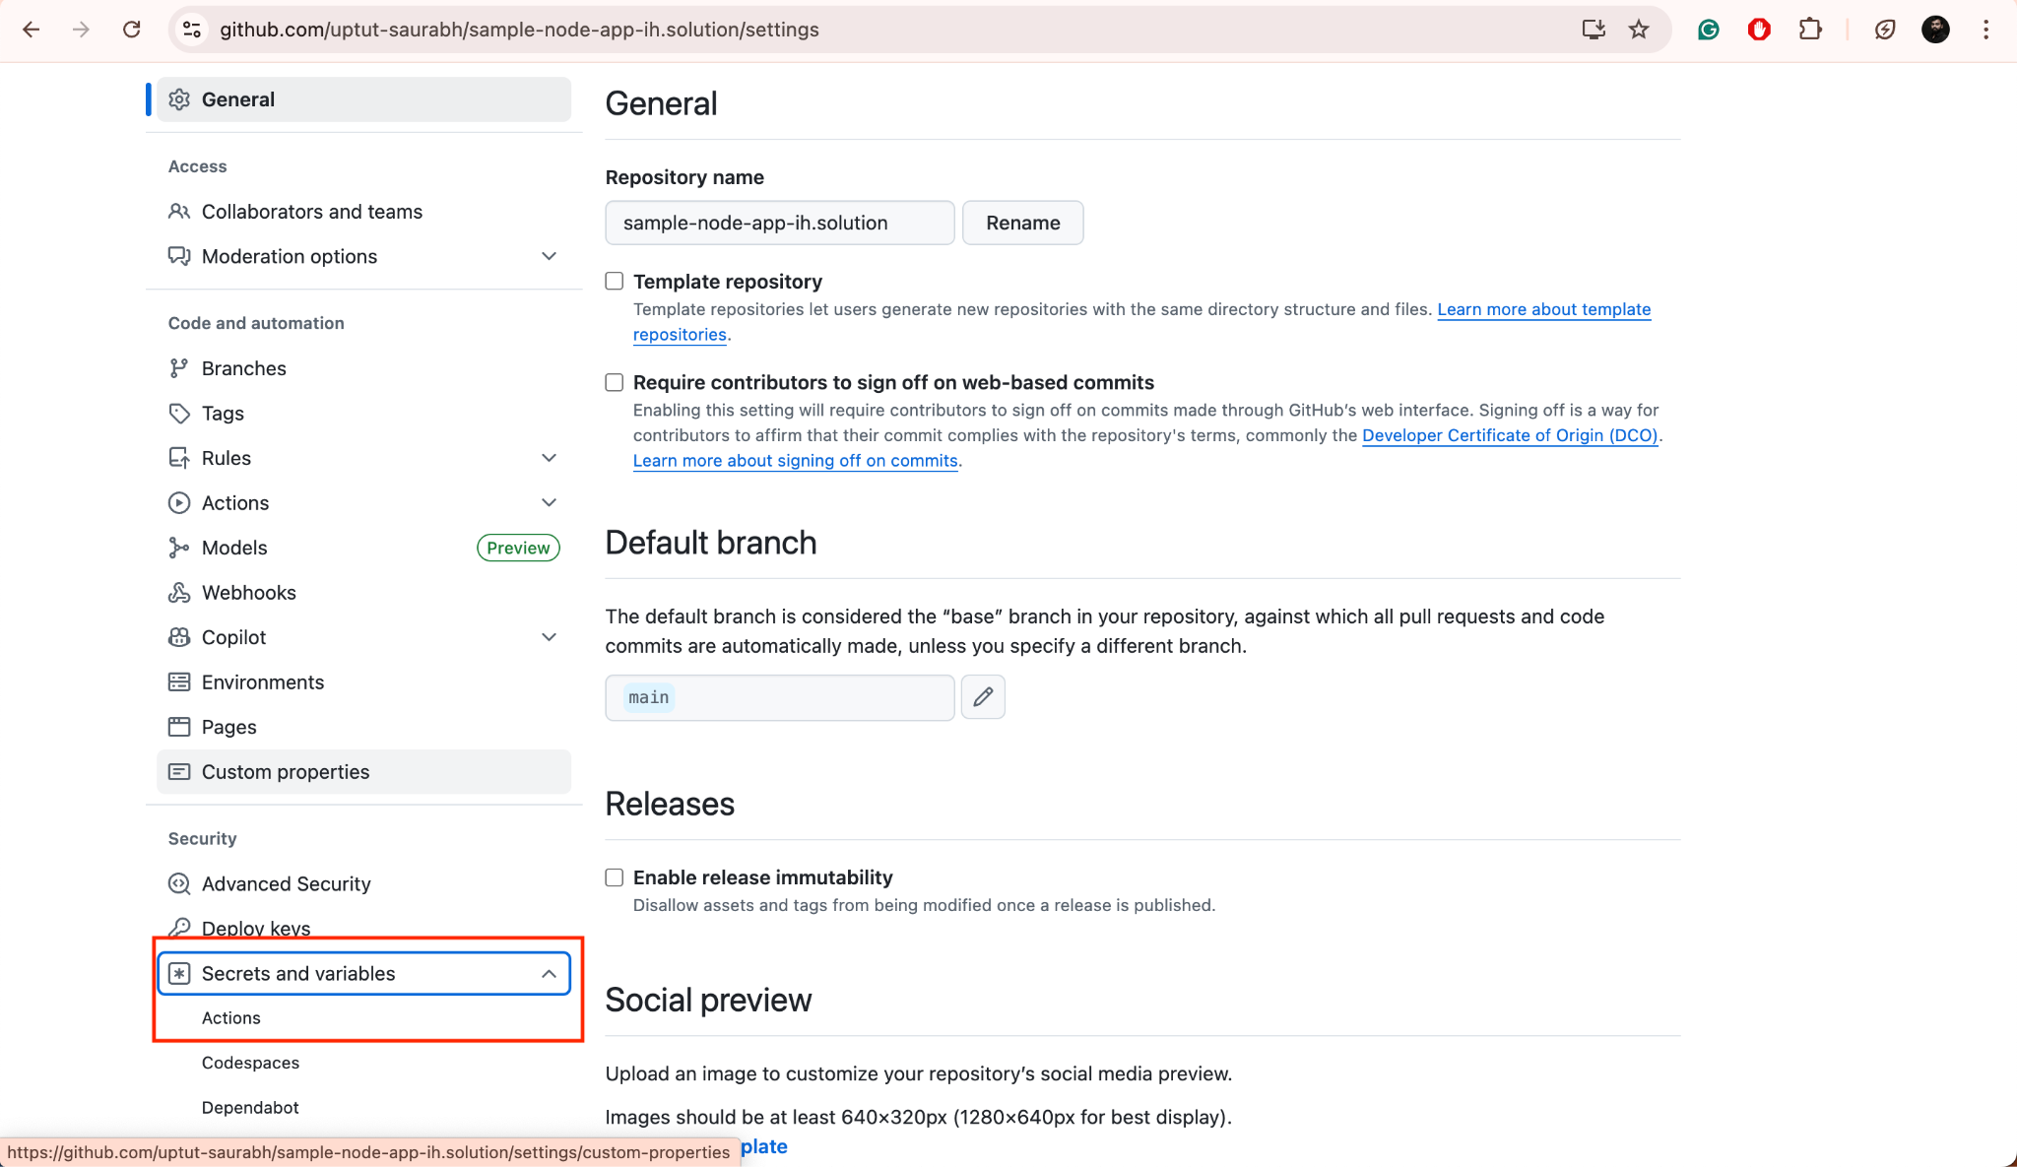

Add an environment by clicking the New environment link, enter the name, say dev.

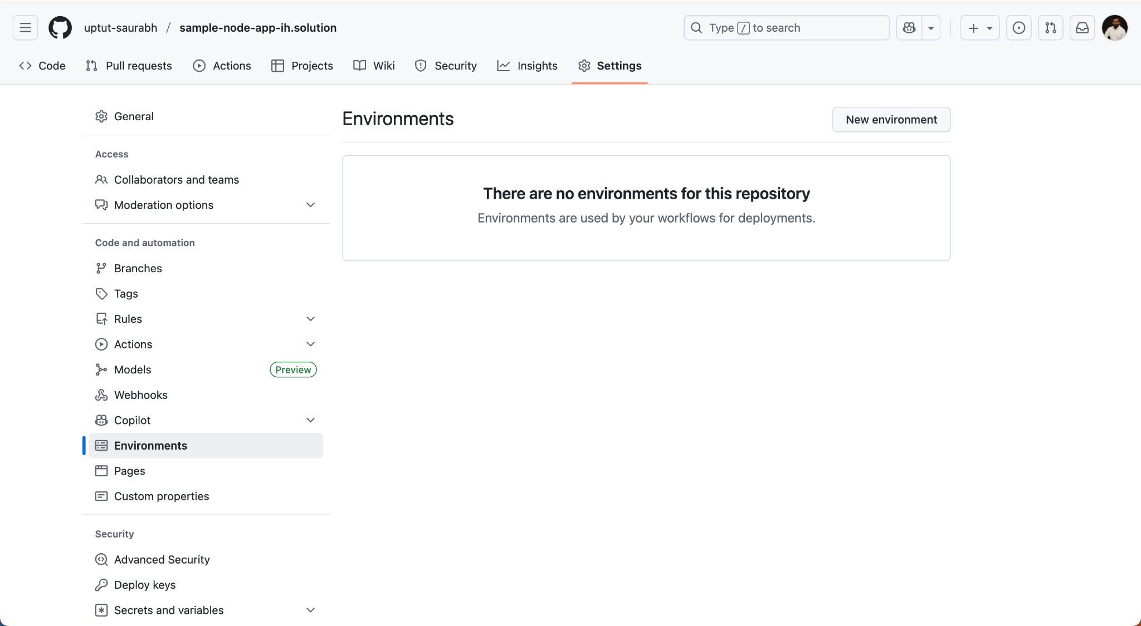

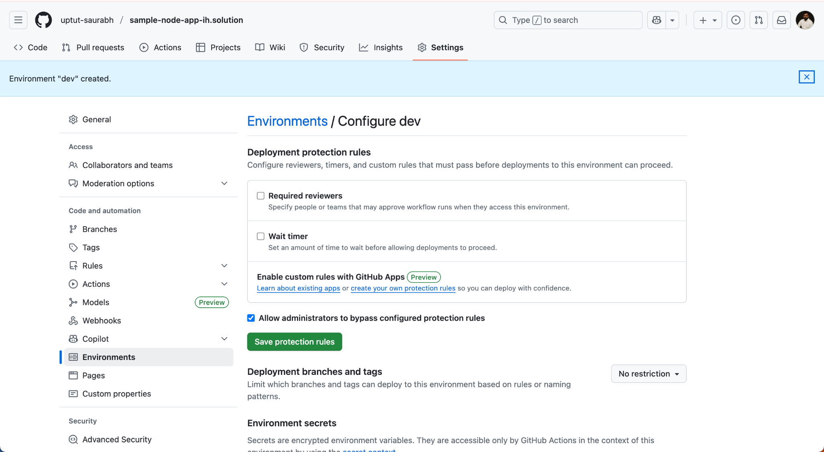
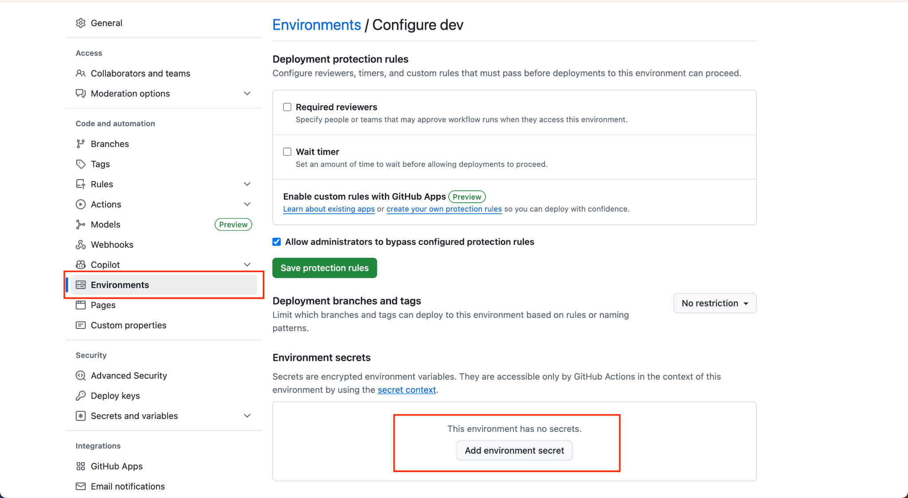
Add the SONAR_HOST_URL, SONAR_TOKEN
To generate the sonarqube token, follow these steps
> Login to the Sonarqube server
> Enter the credentials
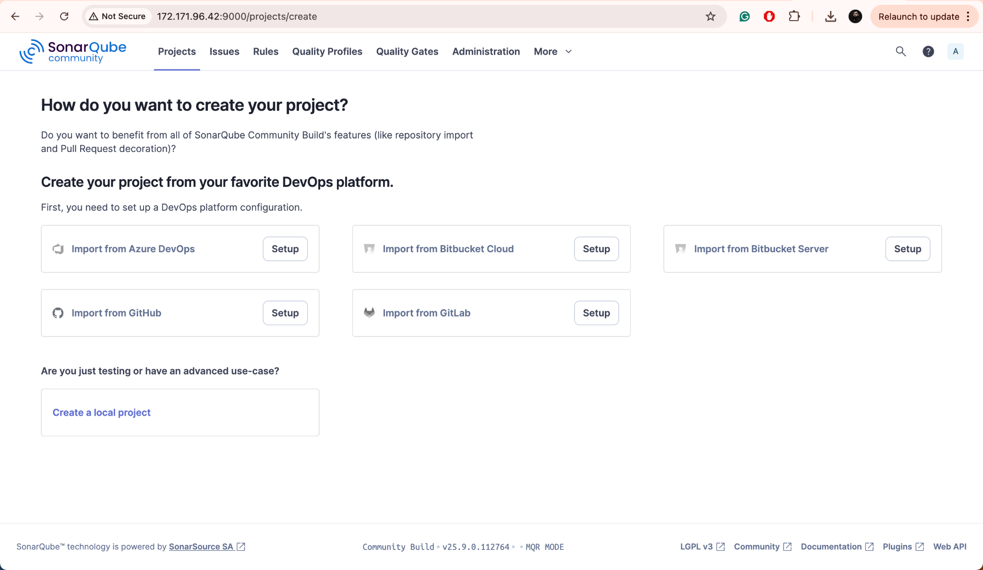
Click on the User Icon > My Account > Security
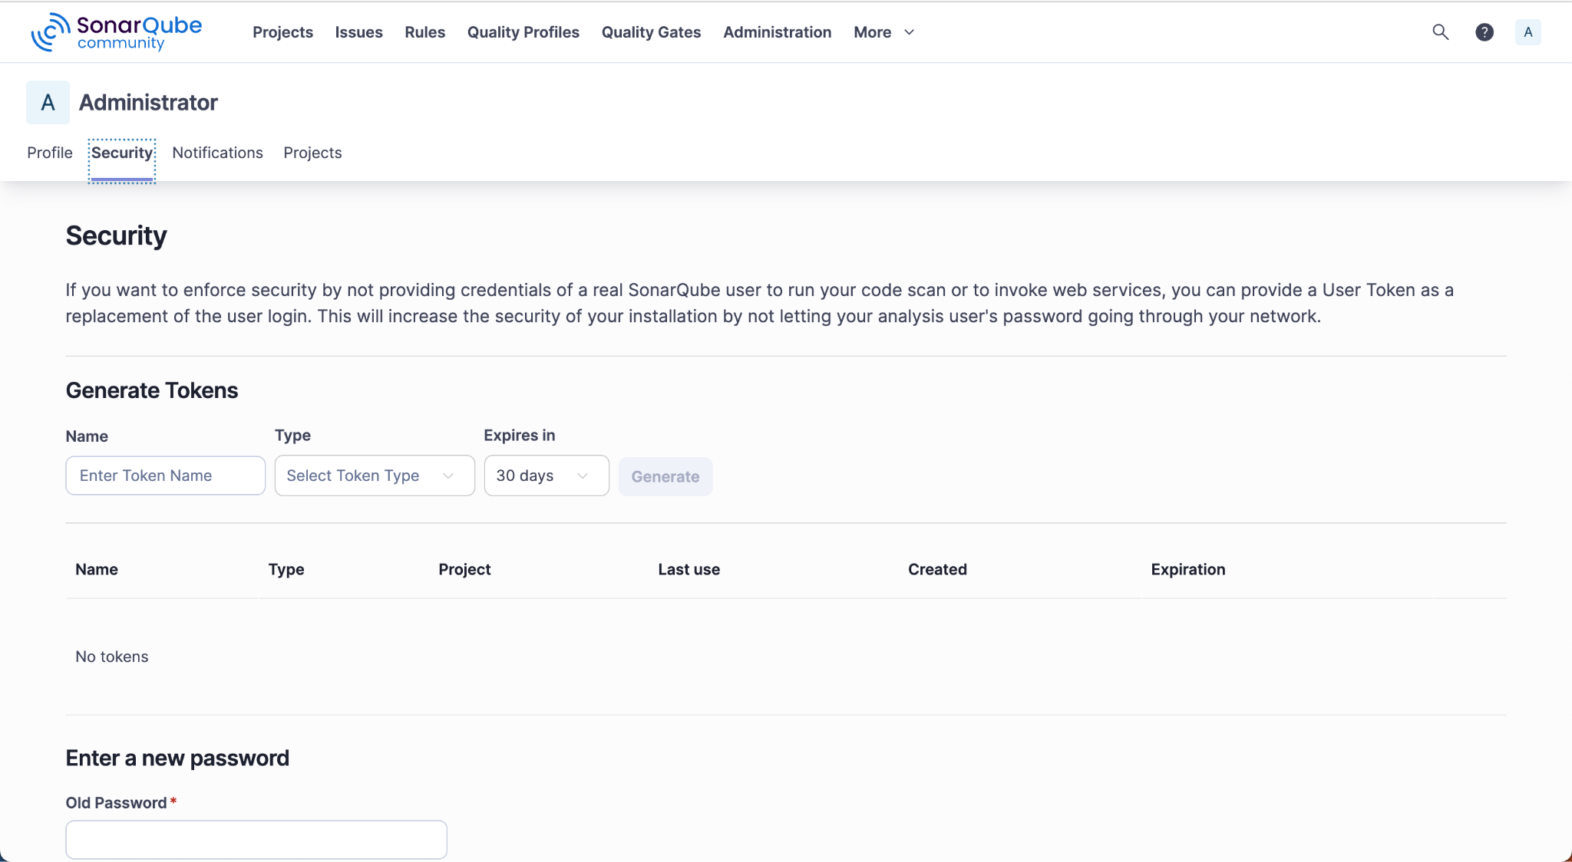

Enter the name of the Token, Type (as Global Analysis Token) and select Expires In - 30 Days, click Generate
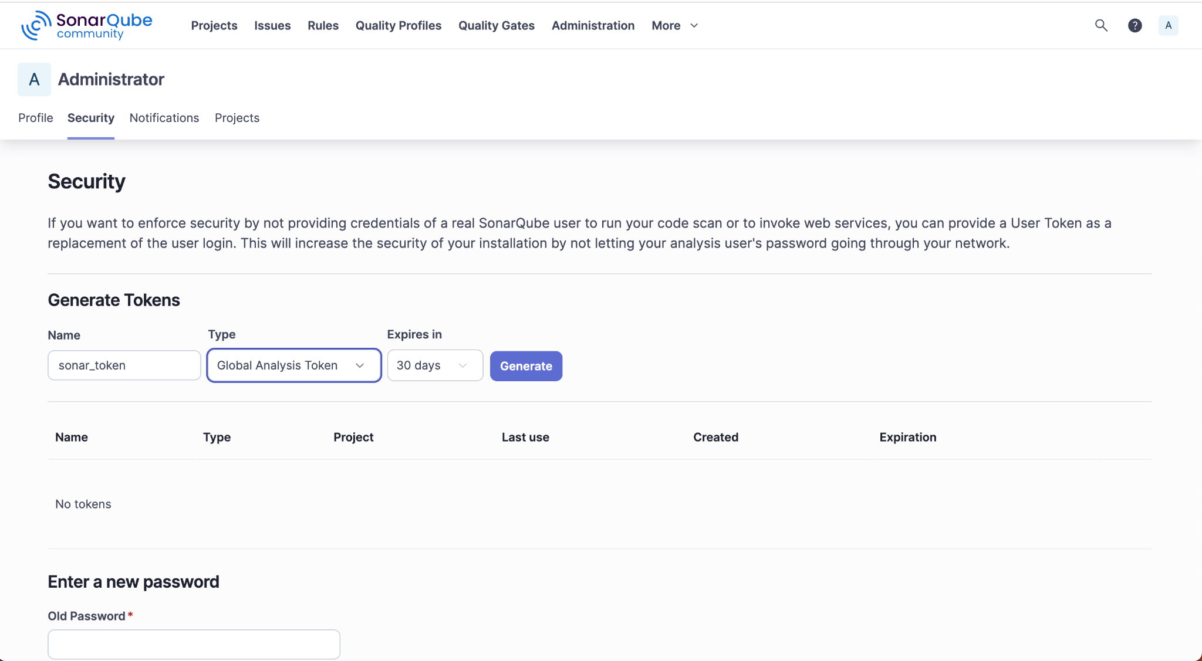

Make sure to copy the token, this token will not appear later so copy and save it somewhere else.

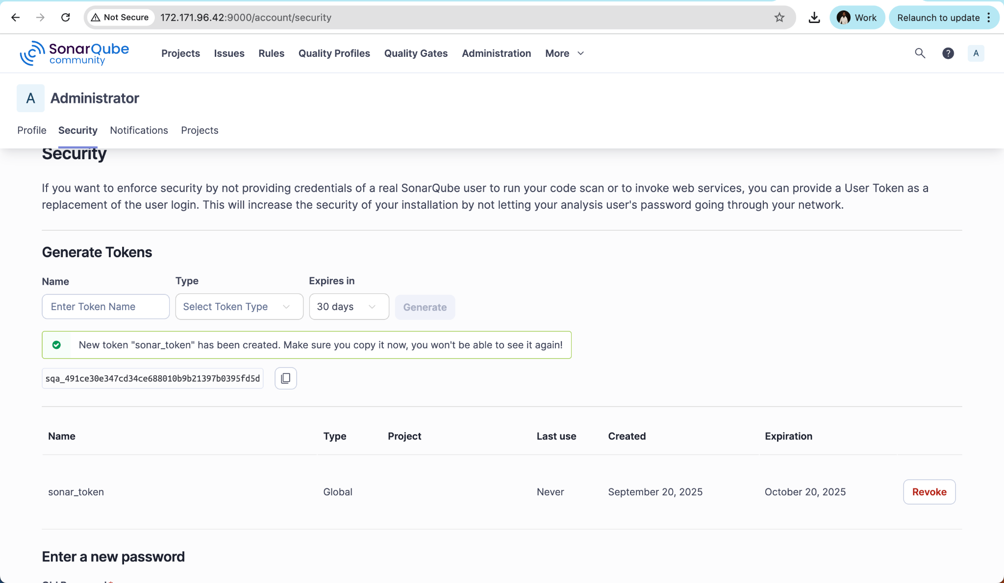

Run the Code Pipeline
- Commit and push the changes to the code repository
- Trigger the Pipeline. It requires a manual trigger as there is no automatic trigger in this pipeline.
- Once the execution is over, you will see the execution as below.

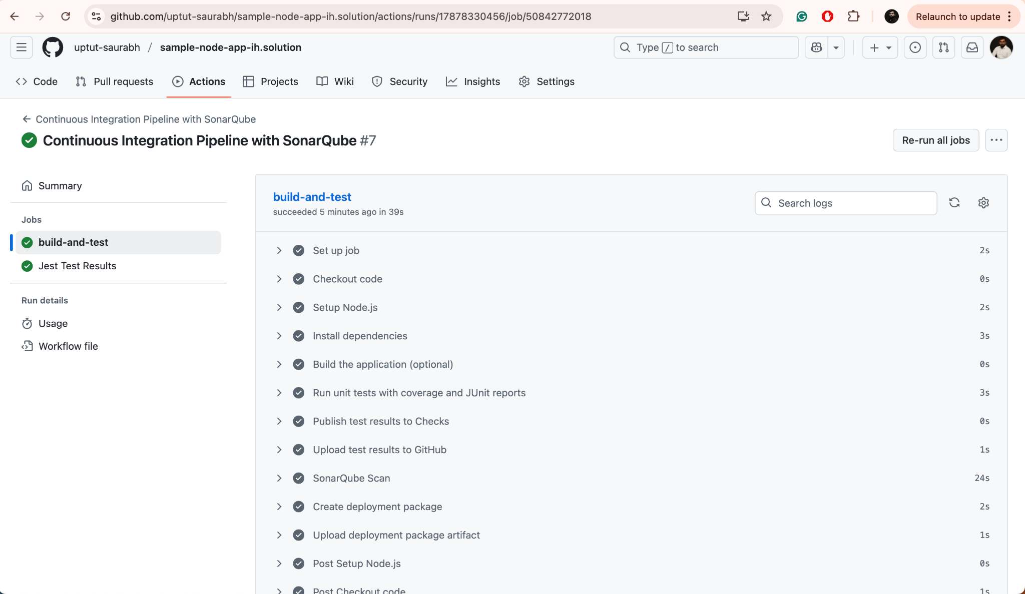

Analyse Report in Sonarqube

Switch to the Sonarqube server >> Projects. You will notice a project report.

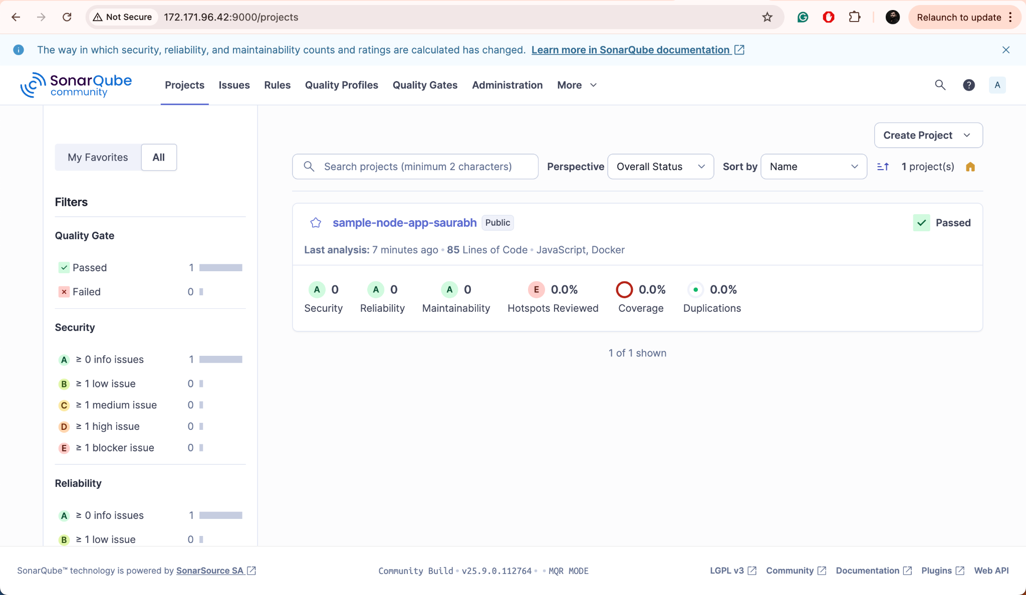

Navigate through each screen to understand more about the report.

